**ARTICLE TITLE (capital letters – Garamond 14 – bold – green)**

Author 1 (Garamond 14 - Green)

Author 2 (Garamond 14 - Green)

Abstract

(Garamond 12 - Grey)

**Key words**: (Garamond 12 - Grey)

Date of receipt: dd month yyyy.

Date of acceptance: dd month yyyy.

Introduction (Garamond 12 – Bold – Green)

Body text (Garamond 12 – Grey – Justified – No indent – Single line spacing – With paragraph indentation, 12 pt.)

…

1. Sections (Two indents before the section – Garamond 12 – Bold – Green –   
In order 1, 2, 3 – Do not use numbering generated with a text editor)

1.1 Subsections (Garamond 12 – Bold – Green – In order .1, .2, .3)

(Garamond 12 – Grey)

Table 1: Table name (Garamond 12 – Grey – Centered)

|  |  |  |  |  |
| --- | --- | --- | --- | --- |
| *CRITERIA OF EVOLUTION* | *COMPARATIVE EDUCATION* | | | |
| “CLASSICAL” APPROACH | | “POSTMODERN” APPROACH | |
| *FORM* | What happens? | Descriptive studies | Interpretative studies | Why it happens (search for explanatory factors) |
| *TIME* | At a particular point in time | Static studies | Dynamic studies | At different times from an evolutionary perspective |

Figure 1: Figure name (Garamond 12 – Grey – Centered)

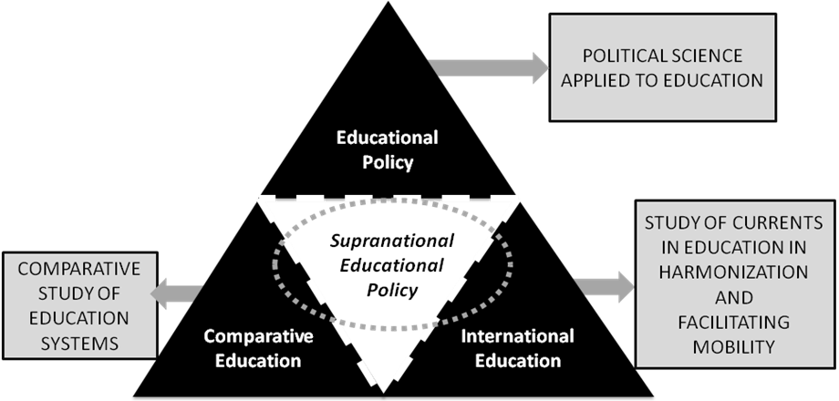

Source: compiled by the author

Footnote[1]

References (Page break before this section – Garamond 12 – Bold – Green)

(Garamond 12 – Grey – Justified – French indent – Single line space – One space for each reference – APA style)

The list of references shall have 1.5 space between elements. Each reference shall have a French indent, and the list shall be arranged in alphabetical order of the authors' names. In case of multiple authors, they shall be separated by "commas" and the latter by the "and". In case of more than two works per author for a year, "a" and "b" shall be added next to the year. Here are a few examples. See full APA standards for other reference types.

{

Books:

**LastName, F. (Year). *Title*. City: Publisher.**

Aron, R. (1968). *Democracy and Totalitarianism*. Barcelona: Seix Barral.

Book chapter:

LastName, F. (Year). Chapter or article title. In F. LastName (Ed.), *Book title* (pp. xx-xx). City: Publisher.

Luzón, A. and Torres, M. (2009). International Education: A New Scenario Between Nations from a Global Perspective. In Mª. H. Martinez Usoraldo (Coord.), *International Education* (pp. 15-55). Valencia: Tirant lo Blanch.

Articles:

**LastName, F. (Year). Article title *Journal name, chapter* (issue), pp-pp.** [If in electronic format, add “**Retrieved from URL**”]

Valle, J.M. and Garrido, R. (2009a). Asymmetry in Erasmus Student Mobility Flows. *Revista Española de Educación Comparada*, 15, 93-130. Retrieved from http://www.sc.ehu.es/sfwseec/reec/reec15/reec1505.pdf

Vallee, J. M. and Garrido, R. (2009b). University Student Mobility: is Spain Attractive for Erasmus Students? *Revista Fuentes*, 9, 98-117.

}

The article text shall mention everything adequately in accordance with the APA style.

**Verbatim quotes: (Last name, year, p.xx)** [If the author was previously mentioned, only **(year, p.xx)**]

If the quotation contains less than 40 words, it shall be inserted in the text and enclosed in quotation marks WITHOUT italics. The period shall be placed after the end of the quote and all data.

Quotes with more than 40 words shall be separated from the text, indented, one point smaller in font size, without quotes or italics. At the end of the quote, a period shall be placed before the data.

**Non-literal quotes: (Last name, year, p.xx)** [If the author was previously mentioned, only **(year, p.xx)**]

About the author / authors (Garamond 12 – Bold – Green)

Author 1 (Garamond 12 - Bold - Italic - Grey)

Body text (Garamond 12 – Grey – Justified – No indent – Single line spacing)

Maximum 200 words.

**Contact information:** University, address, phone number and e-mail address.

Author 2

**…**

1. (Garamond 8 - Grey)